KABORO IAN

SCCJ/00643/2021

BTECH IT

UNIFIED MODELLING LANGUAGE DIAGRAMS

FLOWCHART

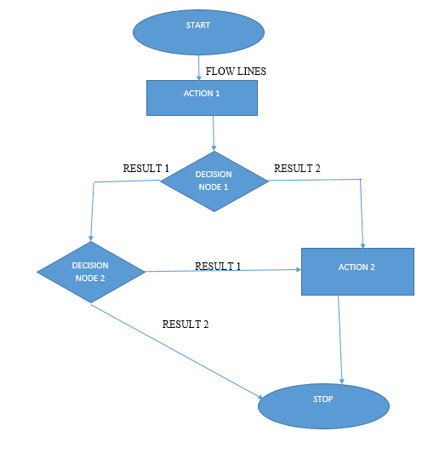

CLASS DIAGRAM

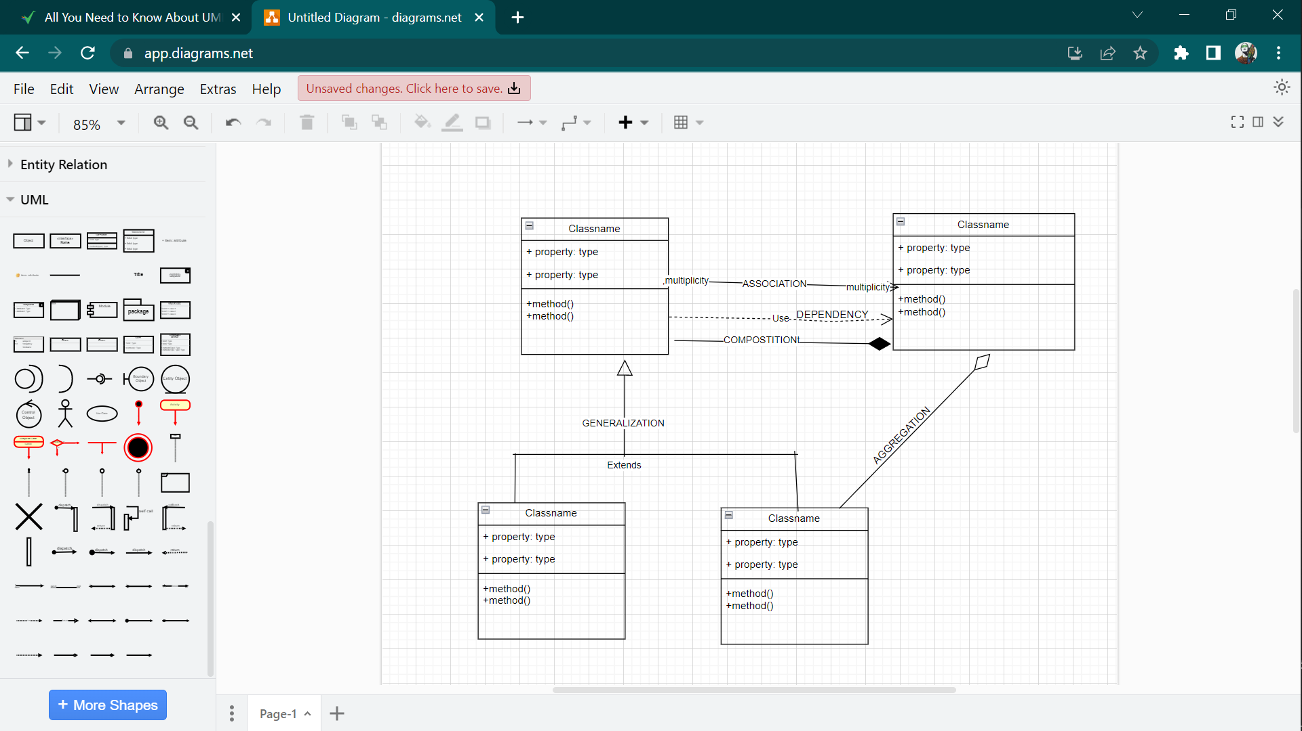

SEQUENCE DIAGRAM

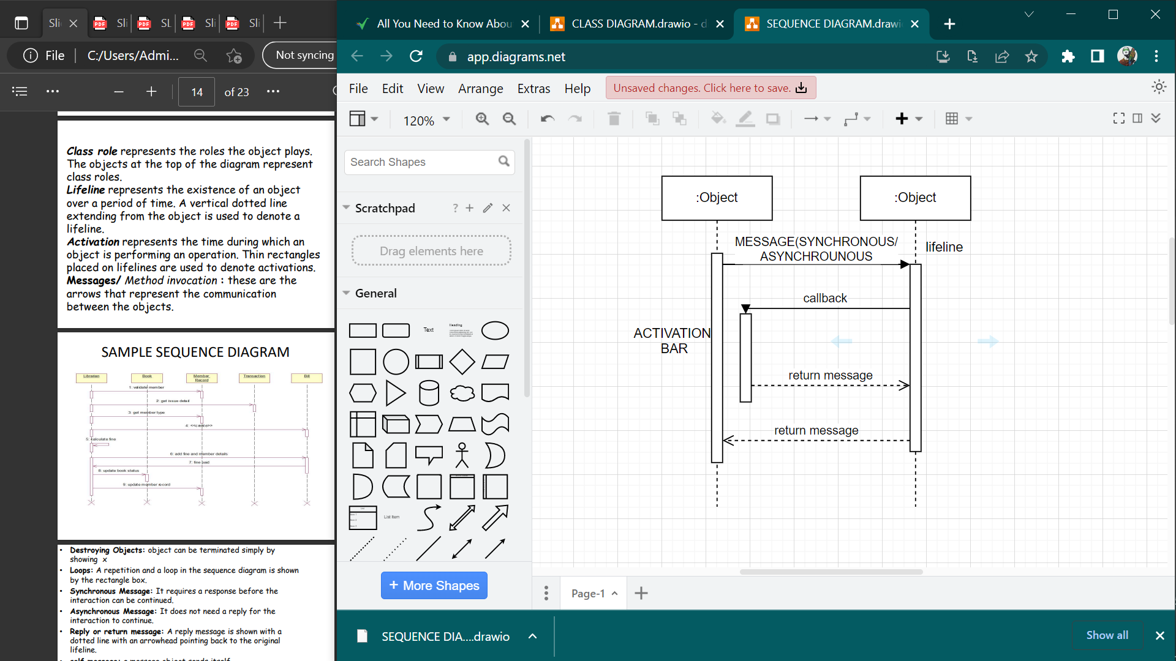

USE CASE DIAGRAM

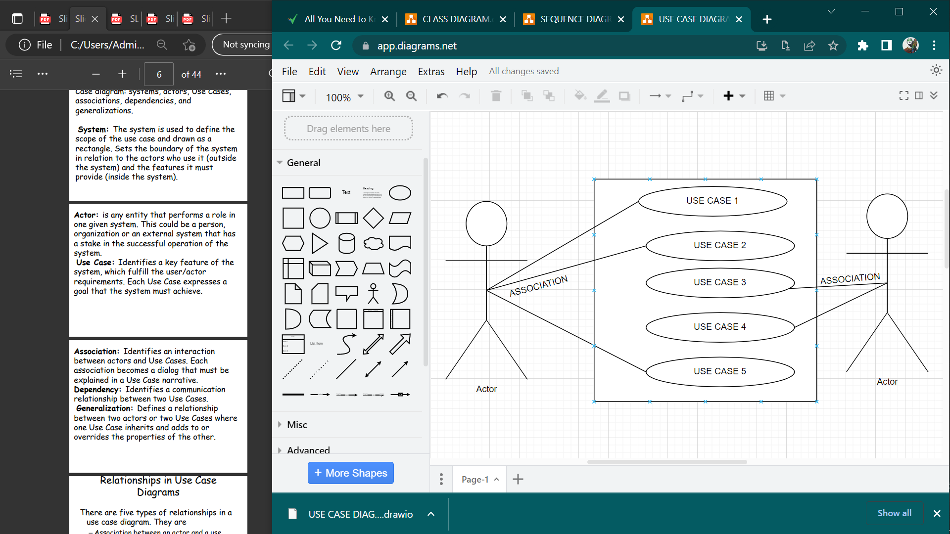

ACTIVITY DIAGRAM

